How to open License Authorization Wizard in Windows 8 to solve license issues.

The overall goal: open the wizard to determine if you’ve already put in a license key, and if it’s the correct one.

Please shut down SPSS before you start:

- Click the folders button in the task bar (on windows 7 you can go to Start->Computer):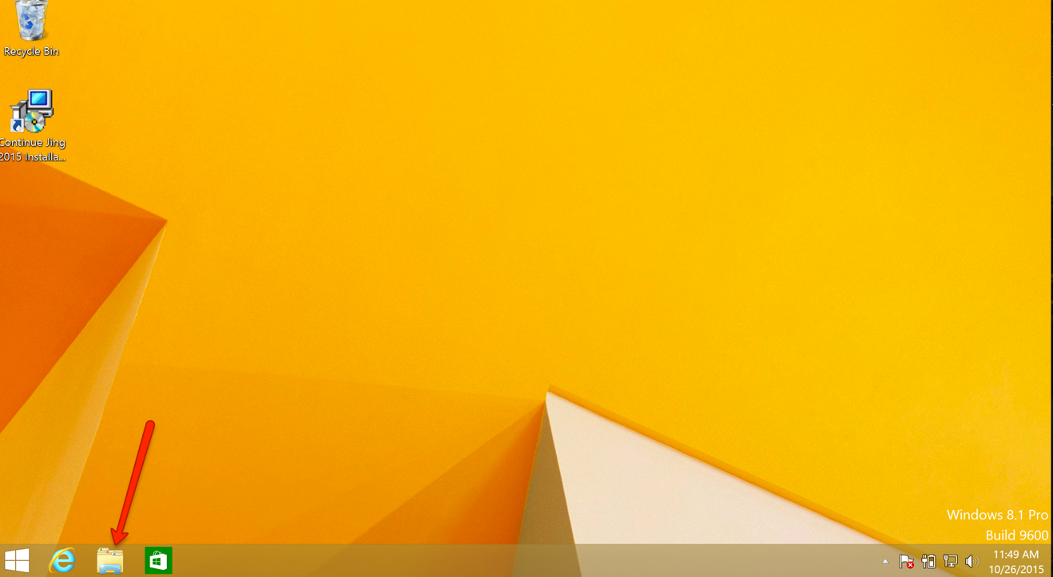

- Find your Local Disk (C:) and open the Program Files folder. You’re going to to be looking for IBM in the Program Files, you may have to check the other Program Files to see if it’s in there

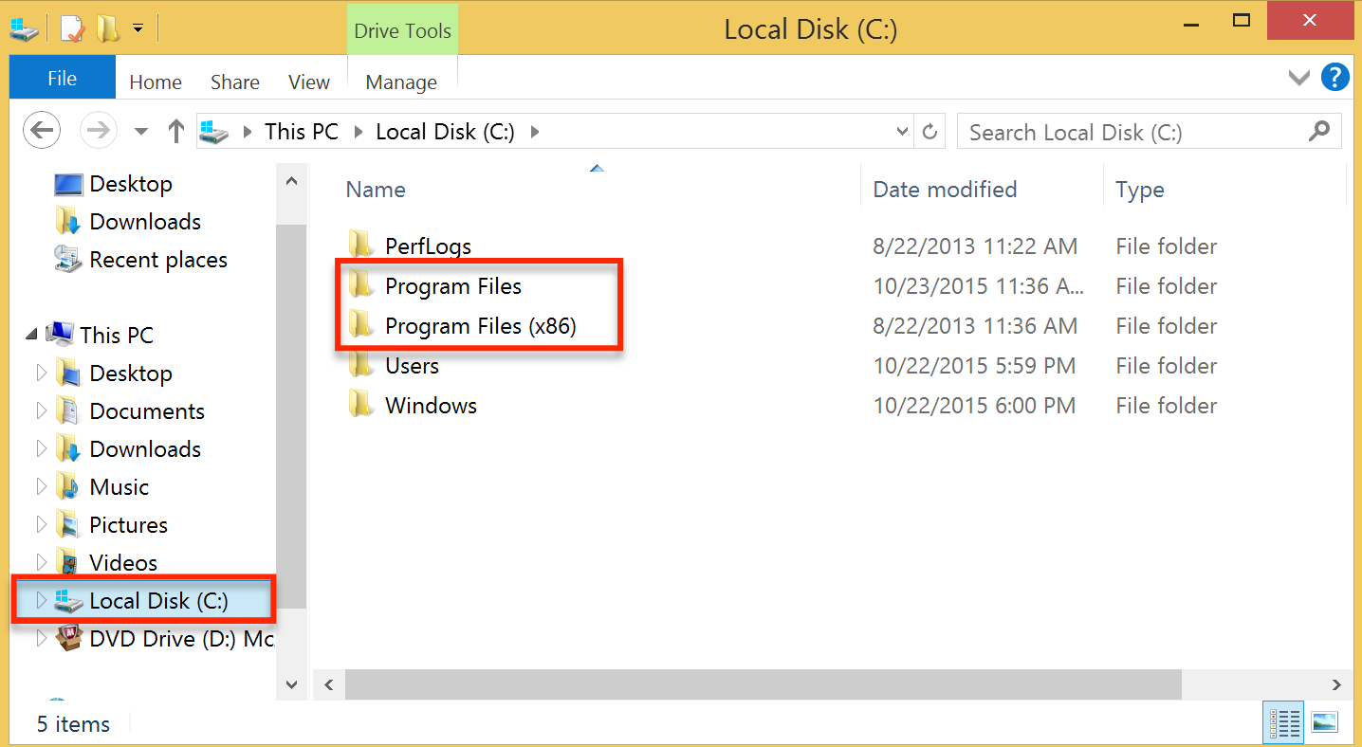

- Open the IBM folder
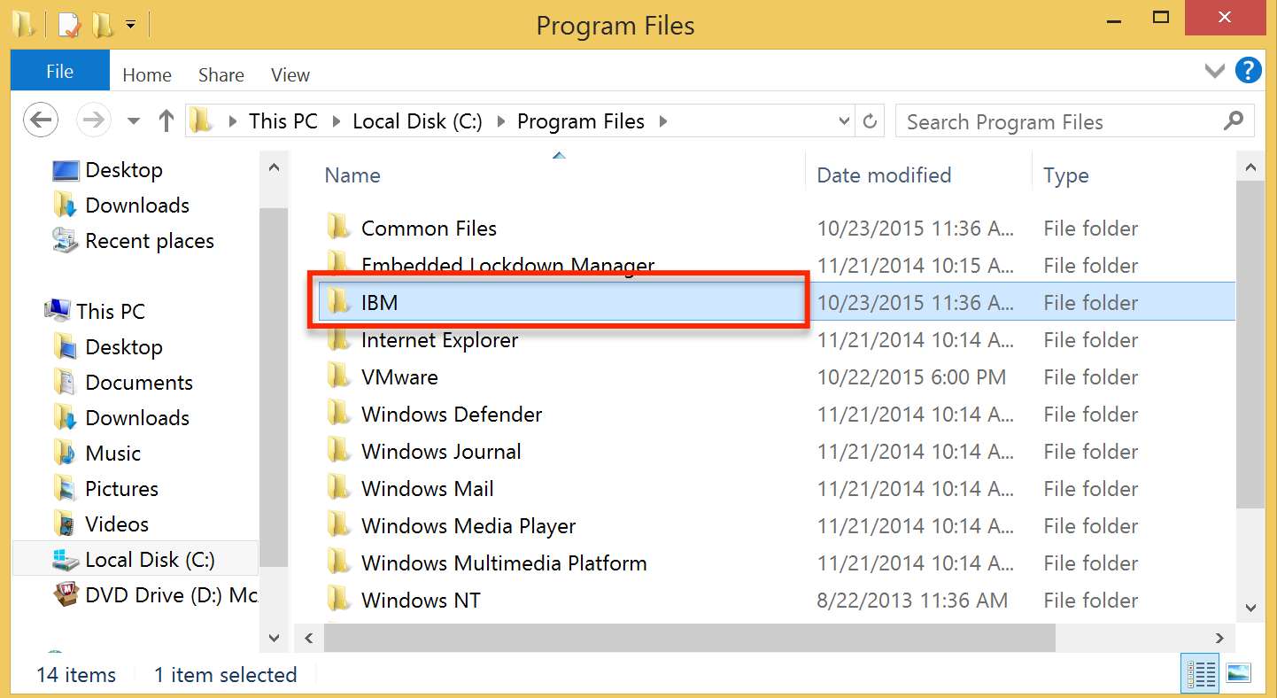

- Click through the folders until you get to the 23 folder. Then look for law.exe
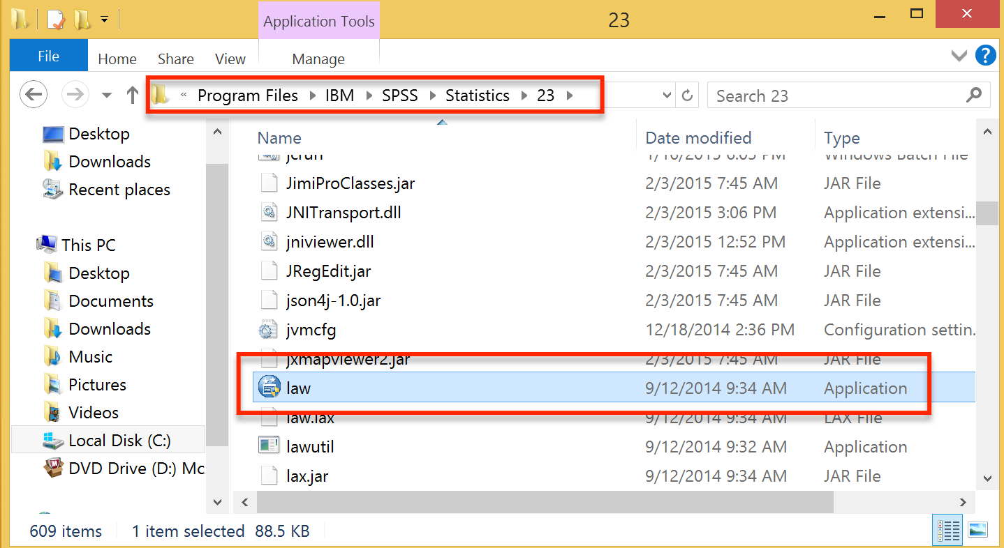

- Right click on law.exe and run as administrator. In this wizard, it will tell you if it has a license code. If it doesn’t follow the prompts to enter one.

