License wizard on Mac

Goal: to help find if there is a valid license, input a new license, or re-license

- Open the finder window and go to Applications -> IBM->SPSS->Statistics->23

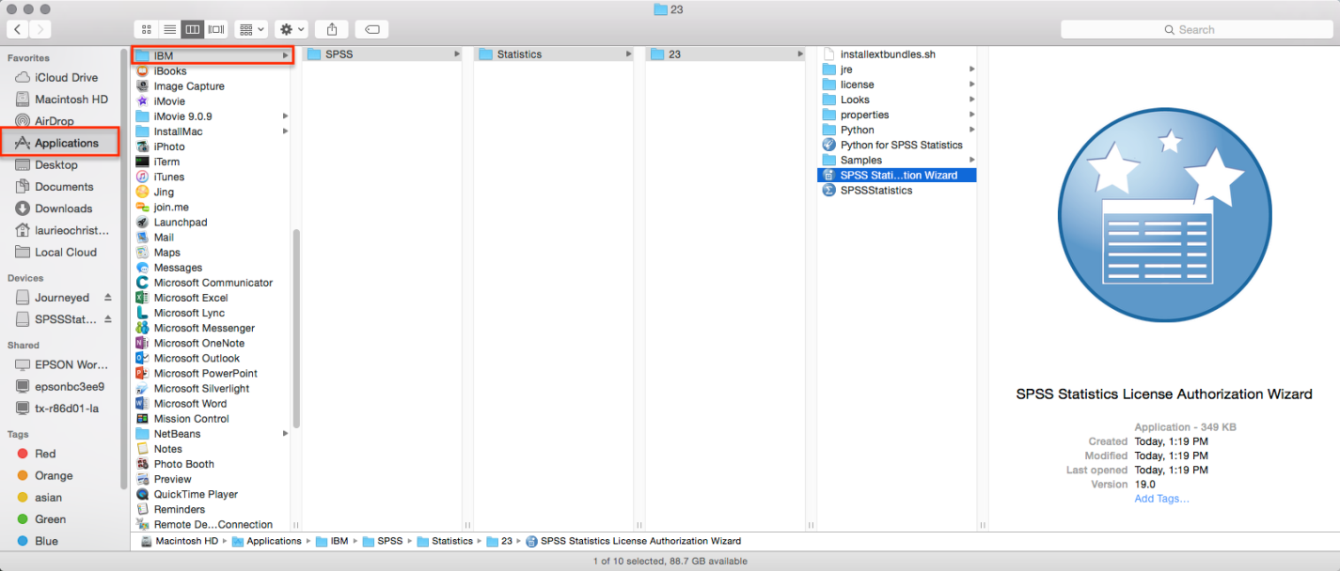

- Double click the SPSS Statistics Installation Wizard and either input your code, or make sure you’ve put in the right code to begin with

